
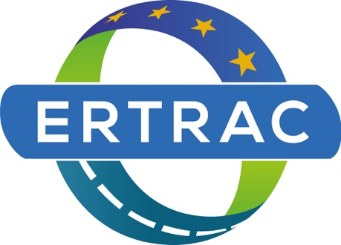
Long Distance Freight Transport
A roadmap for competitive, sustainable and resilient Road Transport

Status: Final
Date: 25.03.2026
ERTRAC Working Group
Long Distance Freight Transport

In collaboration and supported by


Table of contents
1. Scope and objectives 4
1.1. Introduction 4
1.2. Heavy duty vehicles (HDV) main application domains 4
1.3. Facts and figures 5
1.4. Focus areas 8
1.4.1. Customer 8
1.4.2. Infrastructure 9
1.4.3. Energy 9
1.4.4. Vehicles and Services 9
2. Main enablers towards the transition 10
2.1. Electrification 10
2.2. Artificial Intelligence, digital and cybersecurity 10
2.3. Circular economy and value chains 11
2.4. Labor and skills 11
3. Current position and state of the art 12
3.1. Vehicle Solutions 12
3.1.1. Towards Zero-emission vehicles 12
3.1.2. Enhanced services with advanced analytics and AI 16
3.2. Road and digital infrastructure 18
3.2.1. Road infrastructure 18
3.2.2. Charging infrastructure 19
3.3. Connected automated safe vehicles by usage 21
3.3.1. Benefits of safe connected automated freight 21
3.3.2. Business models and market uptake 21
3.3.3. Adequacy of regulations 22
3.3.4. Digital and societal resilience 23
3.3.5. Societal and strategic added value, management of the transformation of the transport/logistics system 24
3.4. Enhance compliance & productivity of road freight transport 25
3.4.1. Improve the productivity of road freight transport by HCV 25
3.4.2. Intelligent Access Program – Corridors 26
3.4.3. Enhance compliance with ‘Weight in Motion’ (vehicle overload detection) 27
4. The strategic roadmap for road freight transport 27
4.1. Wanted Position: Achieving Competitive, Sustainable and Resilient Transport Solutions 28
4.2. Targets for Road Freight Transport 28
4.2.1. Logistics efficiency and emission reduction targets 28
4.2.2. Enabling conditions 31
4.3. Research and Innovation priorities 32

Disclaimer
This document has been prepared by the community of researchers who are members of ERTRAC, and it presents a broad consensus from a diversity of stakeholders. It does in no way commit or express the view of the European Commission, nor of any national or local authority, nor single member of ERTRAC.

Scope and objectives

Introduction
In the context of a ‘truly integrated transport system’ (i.e. self-organized connected and automated logistics, enabling smart intermodal transport and efficient use of infrastructures in all modes), long distance and regional freight transport should become even more competitive, sustainable and resilient, while being affordable for users and actors in the system.
The MISSION is to enable decarbonized, highly automated and connected long-distance freight transport, in order to improve environment, safety and health for the benefit of the whole society, as well as to improve resilience and efficiency of the European freight transport market.
We recognize that the costs associated with the whole transport system are a critical factor. This has direct implications for the market acceptance of zero-emission transport, making it affordable and inclusive, thereby ensuring cost-competitiveness, economic sustainability, and ultimately leading to a resilient transport ecosystem. Business models and innovative incentives systems must be addressed in the upcoming R&I program FP10.
The scope of the ERTRAC Roadmap is to describe long distance and regional transport of goods on roads, taking an integrated systems’ approach. The primary objective is to optimize efficiency and sustainability – by minimizing energy and material consumption, enhancing road safety and capacity, and improving the resilience of synchro-modal logistics.
The aim of this paper is to describe research & innovation actions that will accelerate the implementation of decarbonized and connected, long distance, freight transport, considering the whole ecosystem – including energy production, storage, distribution – as well as customer’s perspective.

Heavy duty vehicles (HDV) main application domains
The needs are different by vehicle usage and application domain. Also, the stakeholders are different. There will be a mixed situation depending on the transport market segment with progressive extension of high technologies to different use cases, from ‘simple’ environments to more and more complex environments.
- Confined Area - ports and terminals versus simple environment: repetitive tasks, private area, fully controlled traffic management
- Hub-To-Hub - from factories to ports or terminals, relatively simple environment: repetitive tasks, partly public road, partly controlled traffic management
- Open roads - highways, roads, complex environment: tailored tasks, public roads, no controlled traffic management
- Urban Environment - cities, very complex environment: made-to-order tasks, public roads, non-adapted infrastructure in dense cities, no controlled traffic management
The different application domains are obviously intermixed in real operations. As an example, hubs and ports are often located in the peri-urban areas. To get the different use cases connected is a key challenge for long-distance freight, and actions should focus on routes connecting the interurban corridors with roads to ports or terminals.

Facts and figures
Learning from the past, we should work on the gaps between research activities and real-world implementation, and on how to accelerate the penetration of innovations and breakthroughs into the industry. One major challenge is how to use heavy duty vehicles in a flexible and efficient way, aligning with diverse needs of the logistics sector – and considering infrastructure constraints. Figure 1.1 presents different heavy trucks used for different purposes.

Figure 1: No truck is like another – Source: Volvo Trucks
Looking at the future, implementation barriers need to be analysed and overcome, potential game changers investigated, and actions prioritized, in order for the road transport sector to influence positively the cross-sectoral challenges of freight transport efficiency.

Key figures of freight transport – All modes
According to Eurostat 2022, road freight transport accounts for 24.9% of transport performance, making it the second most common mode of transport (measured in tonne-kilometres). Maritime transport dominates with 67.8%, while rail transport ranks third at 5.5%. Inland waterways contribute 1.6%, and air transport plays a minimal role with just 0.2%. Figure 1.2 illustrates the modal split of freight transport over selected years.
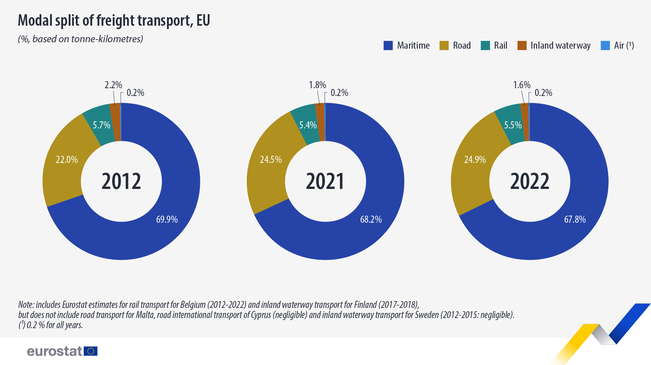
Figure 2: Modal split of freight transport, EU, % based on tonne-kilometres (Eurostat 2022, https://ec.europa.eu/eurostat/web/products-eurostat-news/w/ddn-20240416-1)
In terms of the value of goods, sea transportation represented 47.4% of the value traded between the EU and non-EU countries. Specifically, it accounted for 43.9% of the EU’s exports and 51.0% of its imports. Measured in value, air transportation accounted for 26.2% of the EU’s exports and 17.4% of its imports while road transportation made up 24.1% of exports and 18.7% of imports. Rail transportation had a much smaller share, contributing just 1.5% to exports and 1.3% to imports”.

Key figures – Heavy duty vehicles
According to ACEA, heavy duty vehicle manufacturers are integral to an automotive industry that generates 2.4 million jobs in the road freight transport sector, significantly contributing to the European economy. In 2023, over 603,000 heavy duty vehicles (including commercial trucks > 3.5t) were produced in the EU. Additionally, heavy duty vehicles (commercial trucks > 5t) generated a €6.8 billion trade surplus for the EU, while all motor vehicles (cars, vans, trucks, and buses) contributed around €107 billion to the trade surplus. The automobile and parts sector are also Europe’s leading private investor in R&D, spending approximately €73 billion on innovation in 2023, which accounts for 33% of the EU’s total R&D expenditure. This investment keeps Europe’s heavy duty vehicle manufacturers ahead of global competition.

Energy efficiency, road capacity and safety improvements necessity
The HDV sector contributes significantly to greenhouse gas (GHG) emissions in the EU. In 2021, HDVs accounted for 28% of all EU transport GHG emissions and 6% of total EU emissions. Between 1990 and 2021 (see Figure 3), overall EU transport GHG emissions increased by 18%, while HDV GHG emissions rose by 28%. During the same period, the performance of HDV road freight transport (measured in tonne-kilometres) grew by 17% (ibid).
Huge energy efficiency/ emissions improvement has been achieved over the last decade thanks to R&I activities supporting advanced combustion concepts.
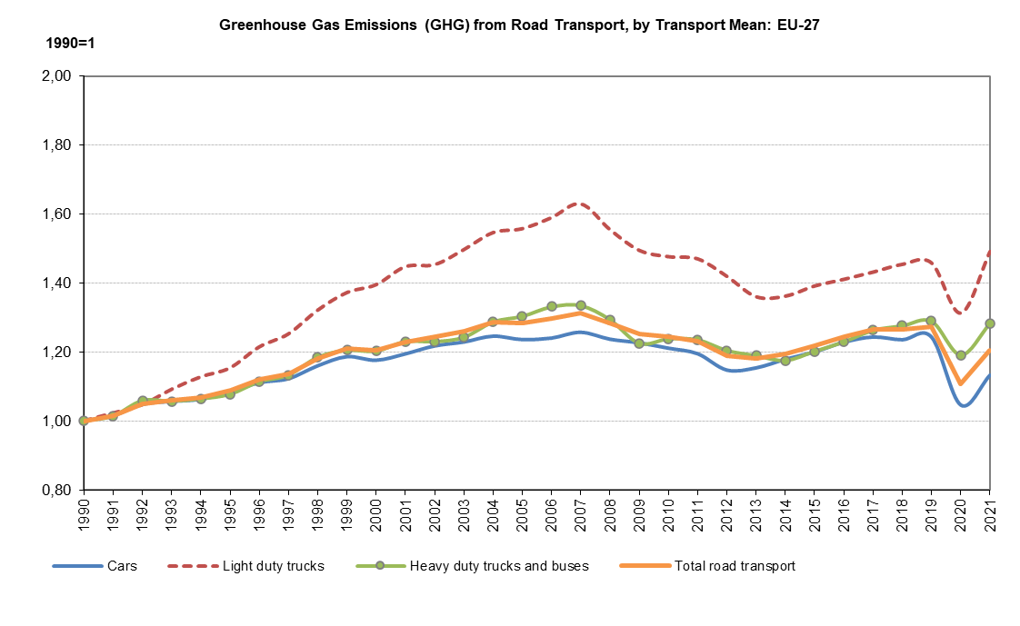
Figure 3: Greenhouse gas (GHG) emissions from road transport, by transport mean: EU-27 (European Commission: Directorate-General for Mobility and Transport, EU transport in figures – Statistical pocketbook 2023, Publications Office of the European Union, 2023)
Improving even more the overall efficiency of long-distance freight transport remains crucial for society in order to continue to address environmental concerns, road capacity (congestion), and safety-related issues. To further reduce HDV emissions, manufacturers must comply with fleet-wide average CO2 emission targets starting in 2025. The HDV CO2 Standards regulation aim to reduce CO2 emissions by 43% by 2030, 64% by 2035, and 90% by 2040.
Congestion in the EU is often concentrated in urban areas. Heavy duty vehicle is the main driver of infrastructure wear damage, as for pavement and bridges (cf. Chapter 3). Lack of appropriate parking places causes additional safety issues from extra driver fatigue. Road utilization could be further influenced by emerging methods of organizing road freight transport and logistics to accommodate increasing e-commerce, new technologies (e.g., automation of trucks and processes), and new trends in work organization impacting the labour environment.
Regarding safety, European roads are considered the safest in the world today. However, fatality and injury figures have remained nearly constant over the years (ibid). In 2022, heavy duty vehicles are involved in nearly 15% of all road traffic fatalities and are significantly affecting work zone crashes, tunnel and bridge safety.

Focus areas
We need to work with the whole transport system consisting of customer, infrastructure, energy and vehicle, as well as with the EU and national authorities to improve the overall efficiency. Research should be conducted on various components and sub-systems (Figure 4) to ensure proper integration. This approach will facilitate better-coordinated development of technologies.

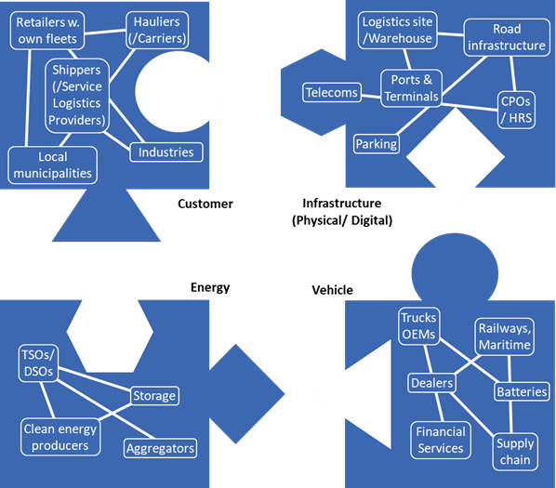
Figure 4: Focus areas

Customer
The demand-side of the transport market is crucial to get the whole new renewable energy-based system coming into place. The transition will be driven by users in the end. Customer requirements and acceptability is the cornerstone, and the total cost of ownership (TCO) is one of the main drivers for it.
The cost of the transition cannot be borne by a fragmented industry with small ‘carriers’ or ‘hauliers’ with very thin margins. So, we should understand how much society (logistics providers, shippers, industries and citizens) is able to pay for decarbonized transport, and who the main beneficiaries of the green transition are, in order to consider feasible and effective value sharing models.
It should be mentioned that the driver also plays an important role. In the short term, driver behaviour is one of the most effective way to implement quick solutions and reduce CO2 emissions.

Infrastructure
As shown in Figure 4, infrastructure encompasses in this roadmap: Infrastructure related to renewable energy, Road infrastructure, Digital infrastructure.
Regarding infrastructure for renewable energy, there is a need for substantial investments to improve access, distribution and costs reduction for renewable energy – included in the electricity grid. The scaling of new technologies should be coordinated to the deployment of new renewable energy production and distribution, as well as to significative other demand centres.
Electrifying heavy duty trucks will necessitate new charging facilities different from those for passenger cars. The electric vehicle industry is working on the Megawatt Charging System (MCS) to provide high-capacity fast charging. The peak charging power for a single vehicle is huge and transferring this much energy over a short duration requires unique design in the cabling, connector, and charging inlet. Truck charging hubs also need connection to the grid at higher voltage levels supplying much higher power levels than cars. Smart charging, booking, demand and supply side flexibility, based on selected data exchange between infrastructure and logistic systems is essential to optimize cost for society.
Another infrastructure that needs attention is road infrastructure: for the last decades, the budget allocated to road infrastructure in Europe has not been sufficient for maintaining and undertaking usual repair or strengthening actions and adapt roads to zero emission vehicles requirements (i.e. bridges). The need for maintenance and monitoring is enlarging budget demands.
Moreover, the evolution of the digital infrastructure has to run in parallel to enable enhanced connected vehicles services, improved safety as well as optimized infrastructure and asset management.
In conclusion, the accelerated roll out of accessible, safe, cyber-secure and tamper-proof infrastructure that is also resistant to adverse weather conditions, must occur concurrently as the other elements illustrated in Figure 4.

Energy
The uptake of zero emission solutions for long distance freight transport will lead to increased demand for clean energy well-to-wheel. The need for renewable electricity, clean hydrogen and alternative fuels will rise, whilst the need for traditional fossil fuels will decline. Decarbonizing long distance freight transport requires the availability of sufficient green energy at affordable price. The energy system – i.e., energy production, storage and distribution – will need to accommodate an increasingly decarbonized freight transport sector.
There will be some competition to access renewable energy (freight/transport vs other needs such as intensive energy industries), but this could also be an opening for new business models and opportunities.

Vehicles and Services
The technology is available, but the key question is the pace of the twin (green & digital) transition – i.e. the uptake of new vehicles technologies.
Different solutions might be required to accelerate the transition towards zero emission – this is especially true for heavy duty trucks that embrace a wide array of use cases: confined areas, hub-to-hub, highways and urban freight. A ‘realistic’ mix of propulsions technologies for these different use cases needs to be set with regards to TCO and Life Cycle Analysis (LCA) by 2030, as well as beyond (once the energy mix is more certain).
Services are key enablers for logistics performance and efficiency of freight transport. Providing advanced service offerings and optimizing services through new ICT solutions are crucial for improving logistics performance and maintaining competitive advantage in the freight transport sector.

Main enablers towards the transition
The Draghi report is underlying that “the industry is undergoing rapid, profound transformation” and that “the automotive supply chain in the EU is currently suffering competitive gaps, both concerning cost and technology”. “The automotive sector is undergoing the biggest structural transformation in over a century” including electrification, AI and digital, and circular economy value chains – as explained in the below sections.

Electrification
While EU climate policies set ambitious targets for zero emission road transport, the whole ecosystem needs time to adjust. We face barriers for adoption of EVs at scale. ACEA has identified that “Consumers and commercial transport operators still face major barriers, including insufficient charging and hydrogen refilling infrastructure, limited operational convenience, high total cost of ownership, affordability concerns, and high energy prices.”
The availability of charging and refuelling infrastructure for low-emission vehicles is a key enabling condition for the take-up and development of a large domestic market for EVs. Grid access of sufficient capacity for charging, affordable electricity price, access to space for recharging of refuelling are also relevant constraints for charging infrastructure.
The paper ‘Drivers for and barriers to electric freight vehicle adoption in Stockholm’ reveals several challenges which are categorized as internal, external or governmental. As a result, the shift to zero-emission mobility remains highly challenging.

Artificial Intelligence, digital and cybersecurity
Artificial intelligence (AI) and digital technologies is revolutionizing connected vehicles, advanced controls for driver support, and autonomous vehicles. Gartner's Tech Trends on Manufacturing provides an impression on the pace of development due to the exponential AI progress. This should also be relevant for the speed of development related to Long Distance Freight Transport and Logistics. AI agents, “automated tools that take on specific tasks” will become essential for performing practical work that drives efficiency across industries.
Several challenges are hindering AI uptake in the freight sector. These include data quality, data and system interoperability, lack of regulatory clarity and common standards for data exchange in some cases, as well as liability issues and concerns about bias in AI decision-making.
AI is also reshaping the cybersecurity landscape. A WEF report calls for a balanced approach that connects AI’s capabilities to protect digital infrastructures while vigilantly guarding against its potential misuse. A significant risk may be that AI could be used more than anticipated. For example, drivers might access the system via API and perform route optimization based on personal preferences, including connections to other data sources. This is possible today and does not require knowledge of Python or other programming languages; users can simply write free text prompts to an AI. Although this practice is not permitted, it cannot be easily governed.

Circular economy and value chains
The automotive manufacturing industry is among the largest consumers of primary raw materials such as steel, aluminium, copper, and plastics. Recovery and recycling of end-of-life materials extend also to batteries or other high-tech components.
Circular economy will prevent or limit waste from scarce resources, while improving the overall environmental performance. Embedding circular economy principles into its core serves as a strategic asset to enhance self-sufficiency and diminishing reliance on external powers.
The 9Rs of the circular economy—Refuse, Rethink, Reduce, Reuse, Repair, Refurbish, Remanufacture, Repurpose, and Recycle—bolster economic resilience and supports Europe's climate objectives. However, high investment needs, combined with business model uncertainty are slowing down the development of this new value chain.
Finally, securing Europe's supply of critical raw materials and components is a matter of sovereignty and national security. These aspects are only partially mentioned in this paper, as this is extensively handled by the ERTRAC circularity and competitiveness working group.

Labor and skills
In the CISCO 2024 State of Industrial Networking Report for Transportation, the shortage of skilled workers is a major barrier to growth for transportation companies. According to the IRU driver shortage study, “over 7 million truck driver positions could be unfilled by 2028” in the surveyed countries.
These trends are affecting the whole logistics sector and EU’s position in freight transport shows signs of increasing competitiveness challenges, due to structurally higher costs and increasing dependencies.

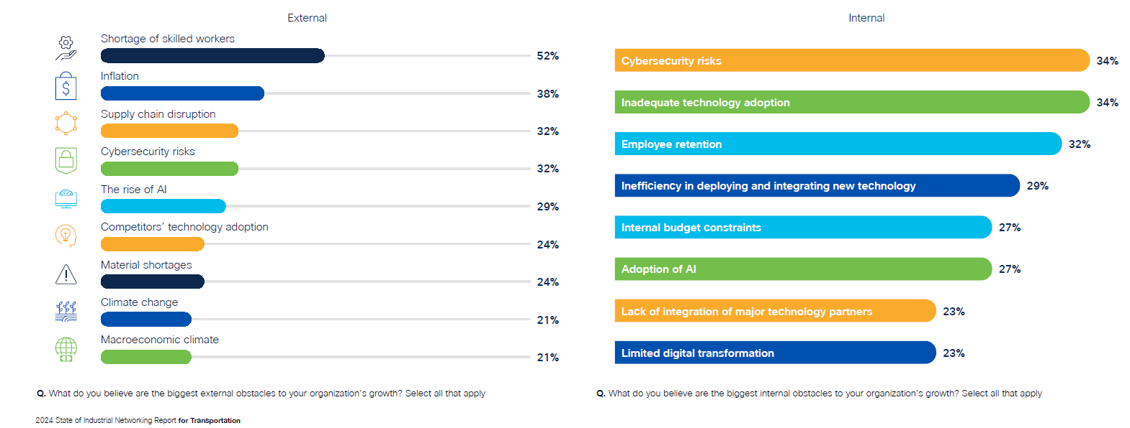
Figure 5: Barriers to growth, according to CISCO2024 State of Industrial Report for Transportation (https://www.cisco.com/c/m/en_us/solutions/industrial-networking-report.html ).
However, this barrier could also be a driving force for introducing new technologies, that could increase the attraction to the profession (e.g. electrification, new planning/collaboration tools limiting the need to be away from home) and make it easier to be a driver (e.g. different types of automation).
However, the driver is not the only concern on the matter of skills. There are also challenges regarding insufficient resources and expertise in other transport related areas – like for building the grid infrastructure as an example, where we are lacking skilled electricians.
More generally and as mentioned in the ERTRAC Road Transport Vision, skills are essential across the automotive industry for Europe to be the first choice for leading researchers, innovators, experts, entrepreneurs. Excellence is needed in education, research, and training for all required skills and competencies, including AI, computer science, power electronics, mechanics, etc.

Current position and state of the art

Vehicle Solutions

Towards Zero-emission vehicles
Most European OEMs intend to have electric products and solutions for all relevant truck segments, also the demanding long-haul segment. However, with a huge range of different vehicles, segments and customer applications, there is no one-size-fits-all solution to achieve zero emission worldwide. We cannot expect every region of the world to have the same energy prerequisites and availability of infrastructure.
We should therefore rely on a three-pronged propulsion approach to decarbonize transport and infrastructure, including Battery Electric Vehicle (BEV) that are excellent from an energy efficiency perspective, Fuel Cell Electric Vehicle (FCEV) - great for even more energy demanding applications or for locations where the grid connection is weak and charging options are few, and the internal combustion engine (ICE) running on renewable fuels (liquid and gaseous), a useful option for customers either transitioning or unable to move towards other sustainable solutions.
There are differences in energy efficiency, cost, and emissions between technologies, but these three alternatives will have a viable position in the market. It will be dependent on customer applications, access to energy, the available infrastructure and the time available for refuelling or recharging in the logistic operation.
The transition into decarbonization also depends on external factors such as the existence of a functioning charging infrastructure and access to renewable energy sources to power battery electric and ICE powered products.
Customer demand in different markets is dependent on factors such as the availability of the necessary infrastructure and energy, governmental incentives for green technologies and the removal of fossil-fuel subsidies. The OEMs will need to have solutions available in pace with customer demand using a highly flexible production system.

Electrification as the main path to decarbonization
Research and innovation in battery electric trucks and fuel cell electric trucks are focused on core technologies to address challenges like range, cost, infrastructure, and operational efficiency.
Battery electric trucks are seeing progress in several research domains: battery and charging technologies, integrated e-Axles reducing weight and improving power delivery, lightweight materials offsetting the added weight of battery systems, thermal management systems with advanced cooling techniques for battery systems, etc. The AEVETO cluster projects, like for example Horizon Europe ZEFES project, are testing various zero-emission truck technologies under real-world conditions to accelerate their commercialization.
Europe is leading in fuel cell electric trucks with advanced Fuel Cell designs improving efficiency, durability and maintainability for heavy-duty trucks. Already some truck manufacturers can achieve operational ranges exceeding 1,000 kilometres, making them competitive with diesel counterparts for long-haul applications. The H2Accelerate Trucks Project is deploying 150 fuel cell electric vehicles to advance fuel cell truck adoption.

Highly efficient low emission ICE with renewable fuels – liquid and gaseous during the transition
Internal combustion engines running on sustainable fuels such as biodiesel - e.g. HVOs, biogas, hydrogen will still play a significant role, particularly during the transition to full electrification where they will serve as a bridging solution.
Research and innovation around internal combustion engines using renewable fuels—including biodiesel, biomethane, synthetic fuels, and hydrogen—are actively evolving in Europe. While technical challenges such as emissions control and fuel standardization remain, collaborative projects between industry, academia, and government are setting the stage for the next generation of cleaner, more efficient heavy duty engines.
To guarantee their increasing availability and role in this transition, the share of renewable fuels in the market must be increased. A revision of the Renewable Energy Directive (RED III) is necessary, to include more ambitious targets. Swiftly increasing targets for the use of renewable fuels in road transport must be set for 2035, 2040 and beyond, with the aim of phasing out all fossil fuels.
While renewable fuels can dramatically reduce CO₂ emissions, controlling NOₓ emissions—especially in hydrogen ICEs—remains a technical challenge. Ongoing research is focused on developing catalysts and combustion strategies to meet stringent emissions regulations.
Researchers are focusing on adapting engine designs—such as modifying injection systems, combustion chamber geometry, and aftertreatment processes—to optimize the performance of renewable fuels. The objective is to enhance efficiency while mitigating NOₓ and particulate emissions, which can be particularly challenging for hydrogen ICEs. Key innovations include:
- Fuel injection modifications – Dual-fuel systems, port fuel injection, low pressure injection and high-pressure injection, …
- Combustion chamber design improvements – Optimized piston shapes, swirl-inducing intake ports, and thermal barrier coatings, …
- Advanced after treatment solutions – Low-temperature SCR, particulate filters for biofuels, and plasma-assisted exhaust cleaning, …
Although several pilot projects have demonstrated promising results, further research is needed to optimize engine performance, durability, and integration with existing vehicle platforms. The work being done now is intended to pave the way for a transitional period where ICEs powered by renewable fuels complement emerging zero-emission technologies.
Hybrid powertrains serve as a critical bridge technology, aligning with the EU's stringent emissions targets while leveraging existing infrastructure and expertise. Recent technological advancements, such as optimized electric motor sizing and energy recuperation strategies, have significantly improved hybrid systems' efficiency, making them a pivotal technology in reducing the CO₂ footprint of heavy-duty vehicles during Europe's transition to full decarbonization.

Renewable and low carbon fuels: Taxation impact on fuels choice
A key ingredient into decarbonization is the availability of low carbon fuels, both liquid and gaseous, either first- or second-generation biofuels (Bio-CNG or LNG, FAME, HVO, BTL, Ethanol, DME), or “e-fuels”, i.e. synthetic fuels using green electricity (H2, e-methane CH4, DME, OME…). However, we should consider that the amount of sustainable biofuel is limited and might be earmarked for the most hard-to-abate sectors in the long term – and that e-fuels product cost is still high (investments and production).
Discussions on the alternative fuels’ options should consider effectiveness in terms of CO₂ reduction in relation to operating costs for operators. Considering the CO₂ abatement costs is crucial, as profit margins for the industry are low (there is a high level of fragmentation in the sector with SMEs making up the majority of operators). Therefore, alternative fuels must be viable, not only in terms of technological readiness but also in terms of commercial feasibility.
Governments can support by ensuring adequate financials. The Energy Taxation Directive aims to have fuels being taxed according to their energy content and environmental performance (rather than volume). However, member states flexibility results sometimes in non-uniform taxation rates, leading to consistency issues (e.g. hydrogen to refuel ICE engine is more taxed than to refuel FCEV in some countries). Taxation rates should be cohesive between fuels according to their carbon footprint – and consistent across-members states.

Long distance trucks and other paths for electrification
E-trailers are trailers equipped with integrated electric systems, including batteries and e-axles. These systems often include dedicated battery packs to power essential trailer functions independently from the truck’s engine, electrified axles with regenerative braking to recapture braking energy and contribute to overall energy efficiency and smart energy management solutions that optimize power flows between the truck and its trailer. This technology is particularly advantageous in scenarios where access to charging infrastructure is limited, such as forestry operations or remote rural routes. By providing additional propulsion and energy storage, e-trailers not only reduce the burden on the primary vehicle's battery but also enable longer trips and more flexible routing in off-grid environments. Connecting the e-trailer and an electric, primary vehicle electrically, could lead to further improvement of the energy management and the driving range (B-trailers), however, to achieve this, appropriate standards and technical solutions need to be established. With pilot projects on e-trailers already in progress in Germany, the Netherlands, and France, the technology is steadily moving towards commercial readiness.
Battery swapping for commercial vehicles is gaining momentum in China as a solution to the challenges of long charging times and higher cost of bigger batteries. The technology offers advantages in terms of rapid turnaround and efficient battery management, but its adoption will depend on overcoming economic hurdles, as the initial capital investment for swapping stations is high. Battery swapping can be highly beneficial by minimizing downtime associated with traditional charging, enabling vehicles to quickly resume operations—crucial for logistics and industrial productivity. A hybrid solution that combines swappable and rechargeable battery systems offers operational flexibility, allowing for fast energy replenishment in time-critical scenarios and conventional charging during off-peak hours. This approach is especially valuable in special use cases like mining areas or remote construction sites, where infrastructure limitations and continuous equipment usage demand efficient and reliable energy solutions. Standardization and compatibility are also a topic: for battery swapping to become widely adopted, there must be consensus on battery design and technical interfaces, which is complicated by the diversity in battery technologies and proprietary approaches from various manufacturers. In addition, operations may become a challenge during the peak times when trucks would need to swap batteries, as this would require larger scale dimensioning of the sites. Insufficiently dimensioned swapping sites could result in reduced productivity for transport companies. The same number of batteries might be required in the end, with a split of quick-charging needs between lunch and early evening and of slow-charging overnight, having a similar impact on the grid.
Electrified roads in Europe have moved to real-world pilot projects: demonstrations have been running in Germany, Sweden, the Netherlands and France – among others. Arguments in favour of adding electrified roads to the charging ecosystem include reduced total cost to electrify all road transport, reduced need for new grid connections, reduced impact on logistic flexibility and timeliness, and a chance to decarbonise EU road freight by 2050. However, the extensive stakeholder coordination, first-mover disadvantage dynamics and substantial initial investment required for installing these systems, whether they utilize overhead lines, conductive rails or inductive charging, presents a considerable barrier to widespread adoption. Planning considerations is a challenge as well as the concerns over additional maintenance coming from the Electrified Road System itself.
In addition, stationary conductive charging systems installed in workshops, ports, and loading/unloading zones is a convenient solution for electric vehicle fleets. By enabling vehicles to recharge during scheduled stops or downtime, these systems maximize operational efficiency without disrupting workflows. This approach is especially beneficial for logistics hubs and industrial sites, where frequent stops provide natural opportunities for energy top-ups, reducing the need for dedicated charging breaks and enhancing overall fleet productivity.
Determining the most cost-effective technological strategy remains a focus of ongoing EU-funded research and development in Europe.

Enhanced services with advanced analytics and AI
Improving the market positioning by providing additional services is becoming increasingly important in most industries. Companies are exploring and implementing new product service systems, bundled service solutions and other types of advanced service offerings. This is about achieving customer value and sustaining a competitive edge. New ICT offer services optimization opportunities and increased competitiveness.
New ICT will support services, facilitating consolidation, synchronization of flows, automation and efficient co-modality – which are all important factors in reaching the targets in the transition towards a sustainable transport system. In addition, charging services will develop, as new transport services with innovative business models like dynamic pricing, etc.
Artificial intelligence and advanced analytics will enhance services, e.g. freight management services, by better optimisation of routes and prediction of maintenance needs. Capacity utilisation and load factor can be improved by better load planning, as well as demand forecasting facilitated by AI.
The services in the transport system can be related to different systems and flows of goods and information (see Figure 7).
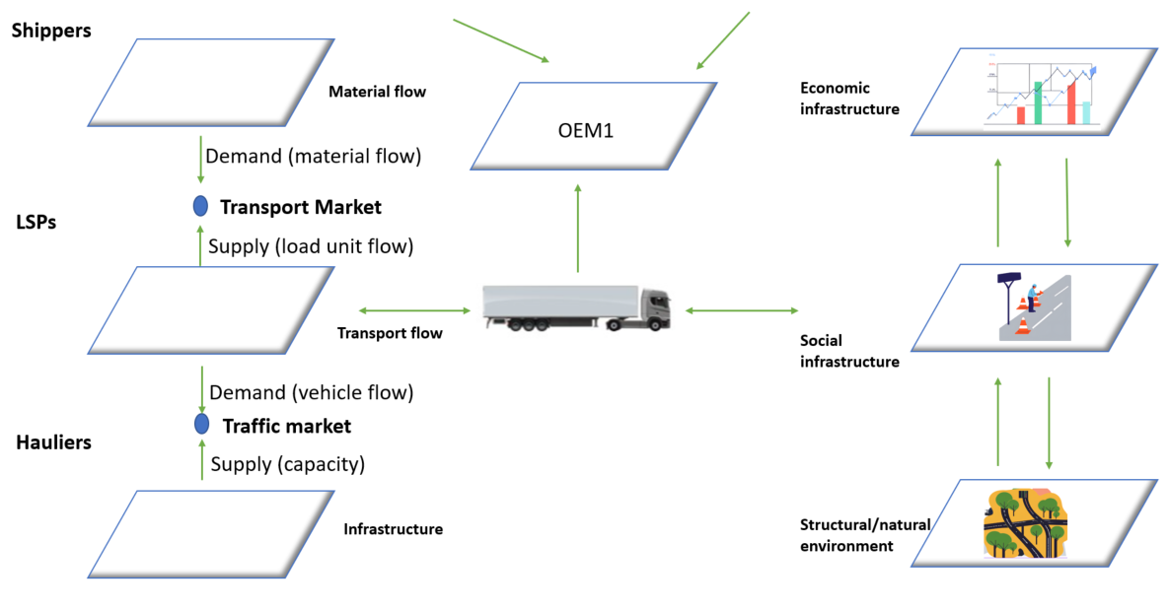
Figure 7: Example of representations of stakeholders in the ecosystem [left part of the diagram has been adapted from Wandel et al., 1992]
Network management, Freight ITS and cargo and vehicle information
Freight transport systems are digitalizing fast, and this gives opportunities at different levels of the transport system: (1) road infrastructure – with traffic seen as users by road authorities, (2) vehicles – with carriers as users and (2) cargo, with cargo owners (shippers) as users. These users all derive value from digitalization through connected business models. The common landscape to store and share data is developing in the EU, moving away from the idea of centralized platforms to decentralized and federated data service ecosystems. Major developments at the above 3 levels are the following:
(1) Road infrastructure: At the traffic level we see improved network management to support logistical process. The Multimodal Traffic Management cluster of projects includes pilots for freight transport and endeavours to include freight traffic as integrated part of traffic management. Important artefacts include processed traffic information into ETA’s (Estimated Time of Arrival). Challenges for traffic managers are the higher economic importance of trucks compared to cars (about double), differences in information needs and safety parameters, and different interests from the perspective of the needs of the logistics process.
(2) Vehicles: At the vehicle level, driven by carriers, we see the development of AI-assisted, dynamic and responsive trip planning tools. OEMs and carriers are driving the increased availability of operational information for fleet management, trip planning and execution and emission reporting. Challenges exist in the rationalisation of planning processes, the physical upscaling of equipment (hardware and software) to connect to shippers and the valorisation of this information by shippers (connecting it to decision making and re-organization).
(3) Cargo: Major developments at the cargo level include, amongst others, the gradual replacement of paper-based documentation by digital information for enforcement reason (eFTI - authorities in all EU Member States will be required to accept electronic data when shared by businesses via certified platforms), digital freight markets for shippers and carriers, digitalization of international cargo manifests (eCMR - electronic consignment note) and improvement of product traceability in the framework of the EU Customs Reform (e.g. DPP - Digital product passports). Challenges include the tension between public and private provisions (regulations, platforms), difficulties to combine and align shipper and carrier information and constraints for the use of (proprietary) cargo information for logistics purposes.
Examples of Services | Actors (non-exhaustive) | Main System levels
- Lane positioning: Adaptation of speed and wheel trajectory  - Infrastructure maintenance needs analysis (including remotely) | Road <> Toll operators | Road infrastructure
- Optimization of routing between mixed vehicle fleets (ZE vehicles and conventional fleets)  - Charging Book & Pay, Parking areas booking (SSTPAs)  - Smart speed: matching loading/ unloading time windows | Transport & Fleet Operators <> Hauliers <> Infrastructure owners/operators | Transport
- Carbon footprint calculation (CO2 Emission)  - Track & trace, Estimated time of arrival, Traffic information, cargo monitoring  - Capacity utilization & load factor (weight & volume, …) | Shipper <> Services Logistics providers <> Terminal operators | Material flow (goods)
Table: System levels, actors, examples of services.

Road and digital infrastructure

Road infrastructure
The traditional, physical road infrastructure is deteriorating, resulting in heightened budgetary requirements. However, available funding for these expenditures is diminishing, while technical expertise in these areas is more localized and/or fragmented. The anticipated demands on road infrastructure are becoming severe, both regarding average (traffic, climatic) loads and extreme weather events. This assertion and its associated issue have been widely recognized in recent years; yet, the suggested solutions have yet to be implemented at larger scale.
The transition to digitalization has resulted in the increasing digitization of road infrastructure. Specifically, the validation of technological bricks has paved the way for the imminent implementation of Condition-Based Road Maintenance, monitoring, and fleet management of vehicles and fleets. Currently, it is imperative to enforce the generalization and upscaling of these procedures.
As shown in the MODI project, all of this is feasible due to data exchange, particularly I2V. However, I2V must be implemented in conjunction with V2I, which will prove to be a challenge due to the availability and format of the exchange data.
The MODI project (A leap towards SAE L4 automated driving features) provides a use case-driven framework towards highly automated logistics for Europe, emphasising the pivotal role of use case development, testing, and data collection within MODI. Five use cases and their real-life applications and demonstration activities serve as the cornerstone for achieving the project's key results and outcomes. To support these five essential prerequisites are required to implement the use cases effectively: (1) CCAM vehicles ready and tested, with verification tests in use cases; (2) Physical and digital infrastructure optimisations integrated and implemented at the use case sites; (3) Evaluation plans in terms of KPIs and data collection plans per use case; (4) Profitable logistics business cases identified; and (6) Validation and demonstration of PDI and vehicles within the Use Cases.

Charging infrastructure
Decarbonization of road transport is largely an infrastructure challenge. Infrastructure decisions made today will affect the competitiveness, sovereignty, resilience, sustainability and equity of the future European energy and transport systems alike. The main technological pathway to zero-emission road transport is direct electrification, i.e., battery electric vehicles (BEVs). While hydrogen, biofuels and electro-fuels (e-fuels) may have some roles to play, fundamental challenges with feedstocks and energy efficiency lead to cost and scalability barriers.
Stationary Charging infrastructure
Key factors in the transition include the development of a network of charging infrastructure accessible to heavy-duty vehicles. This network will consist primarily of private depot chargers, as well as publicly accessible chargers (next to highways or at accessible depots) with adequate charging power that could use Megawatt Charging System (MCS). We should mention that the deployment of charging infrastructure should avoid creating any negative traffic displacement, as Heavy Duty Vehicles should stay on motorways as much as possible.
AFIR is a good start but only a minimum regulation. To sufficiently support the growth of Zero Emission Vehicles, more investments are needed in both number of chargers and grid. With the Clean Transport Corridor Initiative, which seeks to accelerate the deployment of heavy-duty vehicles recharging infrastructure across key freight corridors, the EU is taking a significant step. The initiative will start with the Scandinavian-Mediterranean and North-Sea Baltic Corridors as the first test cases.
As explained in the ACEA/EURELECTIC recommendations “Decarbonizing heavy duty road transport – The role of grids”, HDEV charging demand will exceed local grid capacity by 2030, particularly in urban areas. Unmanaged recharging could result in local peak power demand, necessitating smart charging, substantial local energy storage, or jeopardizing the logistics mission, if not well anticipated. Co-locating renewable power generation, energy storage (with a timeframe from seconds to seasons), and flexible or bidirectional charging has potential to enhance grid stability and reduce local grid congestion. But in any case, anticipatory investments, both hardware and digital, need to be made in grids to secure that increased capacity is becoming available. Lead-times on grid connection or grid reinforcements need to be shortened drastically and regulatory framework including financing models to be modified. Coordinated planning with stakeholders is essential to address public acceptance, land use issues, and establish a feasible power-delivery schedule.
According to ENTSO-E position paper “Deployment of Heavy-Duty Electric Vehicles and their Impact on the Power System”, HDVs might offer potential flexibility services (especially with depot charging) if the right framework is developed, as trucks can charge predictably due to scheduled routes. However, the feasibility of grid services depends on the technical capabilities of the vehicle's battery system. Unlike passenger cars, heavy duty vehicles have significantly higher power demands, larger batteries, and more frequent charging cycles. A clear regulatory framework, incentives, and business models are necessary. The project INSIEME – through the E_HDV use case – is investigating charging patterns and potential roles and procedures of market’s stakeholders for enabling flexibility services.
Dynamic Charging infrastructure
Electric road systems (ERS), which allow charging of vehicles in motion, have been proposed to reduce total integrated system cost. Benefits of ERS include reduced total cost to electrify all road transport, orders of magnitude fewer required grid connections. Dense ERS would enable in-vehicle battery capacity reductions, reducing vehicle weights and costs, and facilitating electric conversion of combustion engine vehicles. Dynamic charging would likely also ease logistical planning and improve charging equity. Major challenges with ERS include large up-front investments in rapidly evolving technology, technology lock-in, natural local monopolies, lack of international agreements on standards, concerns about impact on road maintenance, and resulting slow time-to-market.
Simultaneously, infrastructure investments are long-lived and policy stability and predictability are crucial to de-risk investment in a sector where rapid technology advancements already imply high risks of stranded assets. A resilient transport-energy interface must account for cybersecurity, extreme weather, and geopolitical risks affecting infrastructure uptime. Infrastructure investors may lack internalized economic incentives to design for such resilience.

Connected automated safe vehicles by usage

Benefits of safe connected automated freight
The Industrial Action Plan for the automotive sector builds its first pillar on “Innovation and Digitalisation”. The plan is supporting, among other activities, autonomous driving and establishing a European Connected and Autonomous Alliance.
The terms “automated” and “autonomous” are used to distinguish between level 3 (according to SAE J3016): automation functionalities requiring monitoring by a human driver (“automated”) and level 4 automation functionalities not requiring any in-vehicle support by a human (“autonomous”).
As stated by the FAME project in its Policy brief, “the deployment of CCAM technologies is expected to offer transformative benefits, such as increased safety, enhanced efficiency, and improved environmental sustainability. However, putting automated vehicles (AVs) on public roads faces substantial hurdles, including fragmented regulations, inadequate infrastructure, and limited public awareness and/or trust.”
The main challenge is to ensure the added value is properly perceived by society. Fully connected automated commercial vehicles should enable the logistics sector to:
- Increase traffic safety and reduce accidents e.g. by human errors
- Increase transport system efficiency and improve traffic fluidity
- Enable the driver to perform other tasks
- Allow the transport sector to better cope with the skilled labor shortage
The key areas for implementation are the development of business models, regulatory compatibility, digital resilience, and public acceptance.

Business models and market uptake
To ensure the scalability of connected automated safe vehicles, viable business models must be identified. Shippers and transport operators might have a significant interest in automated driving and logistics, as they are the key stakeholders who would benefit from such advancements. It is essential to focus on resilient Level 4 autonomous systems to facilitate cost reduction alongside the anticipated benefits. Innovative approaches for cost and benefit sharing among involved stakeholders should also be developed. In terms of business models, it is important to analyse how automated vehicles can be integrated into logistics operations, understand the impact on the wider system, and determine potential changes needed to ensure successful implementation.
For the use case connected automated safe driving on long distance routes, the online service platform can take a central role in the operation, in order to link supply and demand, and optimize the operation including hubs/terminals and cargo loads. Also, the availability of infrastructure-based support systems needs to be included in the cost and benefit calculations of the overall system. This especially includes structures where automation function reaches its boundaries, e.g. in tunnels, at toll gates and complex intersections, or in specific logistics areas like logistics hubs or terminals.
The Total Cost Ownership of the vehicles is optimized and instead of trucks – sustainable transport solutions are being offered aiming at optimizing uptime, productivity, vehicle performance and lifetime, as well as reducing logistics labor.

Adequacy of regulations
A key question is whether driverless trucks will be allowed on European highways. While conditional automated driving features like highway and traffic jam chauffeurs have been available since 2020 and require driver intervention, higher levels of automation are used in controlled and confined environments such as mines and ports.
However, vehicle type approval is EU-wide, thus agreement is required. We need to learn from the lessons of EMS in Europe, to ensure that automated heavy-duty vehicles do not suffer the same delays in cross-border implementation. It is necessary to establish uniform regulations for safe linked automated freight both at the European level and among European nations. The FAME project has published a policy brief for empowering Cities to lead CCAM deployment and the same principles apply to long distance freight transport.
Some stakeholders or interest groups (such as labour unions, groups of road users, insurance firms, etc.) may express concerns about changing current regulations to allow autonomous operation. The Vienna convention which defines the driver and his tasks, but also standards, need to be updated to accommodate autonomous vehicles and guide countries at global level. Consequently, the pace of adoption will vary between nations, which could impact the industry and lead to cautious measures, especially for cross-border operations – which is a large part of the long-distance freight – and market opportunities for OEMs. Therefore, it is important to identify a shared path forward.
Currently, there is no uniform regulation and common practice at the European level for testing autonomous vehicles on open roads. Testing with autonomous vehicles require specific permits, given by local or national authorities. This means that authorities need to have the knowledge to assess the permit application and the rules for applying and receiving a permit differ by region.
The European Commission has announced, as part of the Industrial Action Plan for the European automotive sector, a new initiative, the “Large Scale Cross Border Testbeds for Autonomous Vehicles”, to overcome this barrier and support accelerating deployment of connected and autonomous vehicles and services in road transport.

Digital and societal resilience
The widespread use of connectivity in automotive poses serious problems for the sector. Digital resilience against cyberattacks is one of the most important since vehicles or even entire fleets could be hacked by malevolent attacks. Events that erode public confidence in linked automated vehicles could disrupt or postpone adoption if digital resilience is not incorporated into vehicle systems. In the event of a disruption to the digital system, digital resilience means that the consequences are limited to a small portion of the ecosystem or that the operation can continue with backup solutions – which is the fundamental principle.
Moreover, to ensure digital resilience, ALL actors need to embrace cyber security measures across the system stack, which could be an issue.
To achieve this effectively, vulnerabilities that threaten existing vehicles need to be assessed to integrate digital resilience into the design processes to ensure future models are also secure-by-design. This will be achieved through a systematic approach to design that identifies vulnerabilities and mitigates risk in an appropriate way, incorporated into existing risk management practice. This will result in the ambition of vehicles that are both resilient to attack and continue to function safely and securely if breached.
The dependency on the electricity and communication system is complete, which brings about our statement of the interconnexion of physical and digital, road and energy infrastructures.
Software Lock-in due to market power concentration of Big Tech companies leads to sensitivities in the business models. Open-source software such as in the Federate project may be one of the solutions to regain European data sovereignty. Equally important are the initiatives regarding dataspaces such as the Mobility Dataspace and Gaia-X - that may be a way to boost further European digitalization. Interoperability of online platform services is needed to avoid dependency on a single platform and avoid the situation where a winner takes all scenarios.
Nevertheless, dependencies or captivity on software are already a fact, and this may be an issue, with the trend towards software defined vehicles. Through initiatives like the Vehicle of the Future and the SDVoF, the EU fosters open-source collaborations, enhancing innovation and competitiveness in a rapidly evolving global market. Besides managing increased software complexity, the transition to SDVs presents significant challenges also related to cybersecurity, and developing a skilled workforce. Addressing these issues requires coordinated efforts across the industry and support from policymakers to build a resilient and innovative automotive ecosystem.
The integration of vehicles and their associated data in logistical digital ecosystems requires interoperability of systems. The real-time monitoring of the vehicle condition (and its components like the battery), its maintenance needs as well as cargo monitoring are essential (e.g., the calorific power of the cargo, the loads which are linked to the braking possibilities of the vehicle, etc.). For a first step, this can be done with a driver on board, which is already in research nowadays. This puts high strain on connectivity and stability of web connections.
Over the last decade processing communication has undergone a leap forward, and sensing and control technologies now enable automated transport to be realized. Such a change to the adoption or uptake of automated transport could revolutionize ownership models, precipitating fundamental changes in the economics of transport and the urban and, create a new, global industry.

Societal and strategic added value, management of the transformation of the transport/logistics system
Labour currently accounts for an estimated 35 to 45% of operating costs of road freight in Europe, with an increase of 5% y-o-y, driver wages being the fastest-growing cost component. Further, rules on driving and resting (for over a given day or week) limit the speed and reach of long-distance road freight, where individual drivers are allocated to each truck. At the same time, road freight operators struggle to attract drivers to undertake such long-distance trips. Clearly the possibility opened by automation to change the labour costs input total freight costs, and offering better working conditions will lead to an increase of vehicle productivity and would be of great interest to road freight businesses and their ultimate customers, without forgetting that the driver will remain a key figure.
According to the IRU report ‘Managing the Transition to driverless road freight transport (2017), the operating cost reductions are likely to be significantly higher in long-distance freight where drivers will account for a greater share of the cost base than in urban/short distance freight. Overall, operating cost reductions for long-distance freight are possible under driverless operation. Indeed, the driver is more essential at loading and unloading. The driver could turn into a fleet operator role. With growing transport demand and labour shortages, automation where needed on long stretches, would provide some relief and improve the resilience and competitiveness of the EU logistics scheme.
One consideration for ensuring societal acceptance is the localization of drivers/employees dealing with autonomous trucks. It would be possible to select employees from different regions where salaries are lower. However, remote operations require both an understanding of the vehicle and knowledge of local traffic rules and conditions, such as weather and visibility. Additionally, remote operation centres may be legally required to be located near the area of support or at least within the same country to comply with specific local, regional, national, or European requirements. Therefore, these jobs will remain localized in the same area.
Connected automated vehicles provide the opportunity to revolutionize the trucking industry and the way fleets operate. If used properly, automated commercial freight vehicles could improve fleet efficiency, flexibility, and the total cost of ownership. It has also great potential to effectively reduce traffic congestion-related costs through vehicle platooning, improved driver behavior, reduced driver costs, and increased fleet mobility as well as safety.

Enhance compliance & productivity of road freight transport

Improve the productivity of road freight transport by HCV
The pending revision of the Directive 96/53EC will reopen the question of the European Modular System (EMS), as required by the European Parliament (decision of March 2024). The Commission proposes to allow cross border EMS between Member States that are already authorizing them for National transport (on main corridors), and to limit the accessible network to specified routes, adapted to the EMS. For reference, EMS1 combinations are tractor and trailers configurations of up to 25.25 meters and 60 tonnes max while EMS2 up to 30 or 33 meters and 74 or 76 tonnes maximum weight.
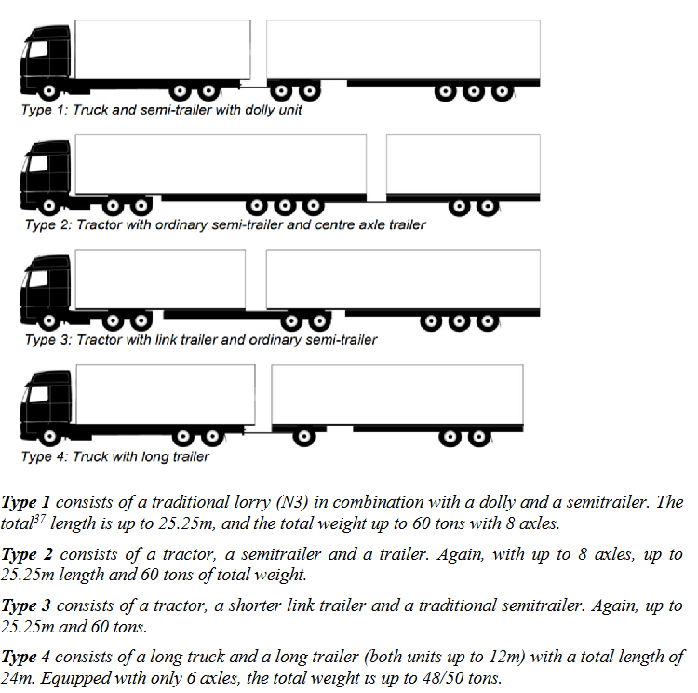
Figure 6: Summary of possible EMS configurations (extracted from ).
The EMS2, allowing to combine two T2S3 in one combination (T2S3 + dolly + semi-trailer), is much more efficient and productive, because two lorries are replaced by one (instead of 3 by 2 with EMS1), and there are much more T2S3 in Europe than lorries with trailers. The volume of the payload is twice as much with an EMS2, while only 50% more with EMS1. Fuel efficiency and emission per t.km is also better with EMS2 (approximately a gain of 5 to 10%) than with EMS1. The maximum authorized weight may finally be less than the upper bounds given above, to better protect the existing bridges, and because the carriers mostly need more volume than weight. However, if the EMS fulfill a bridge formula (existing in the USA, but to be proposed and calibrated for European bridges), the impact on bridges will not significantly increase. Nevertheless, in-depth studies need to better describe these impacts and monetize them by comparing all advantages and drawbacks for various European corridors.
To ease the deployment of BEVs with enough range to drive 4.5 hours (and reload the battery during the pause), HGVs will require approximately 650 to 750 kWh, i.e. 4 to 5 tons of batteries. Therefore, the increase of the self-weight of BEVs should be 4 tons compared to a diesel HGV (the electrical engine is smaller and lighter, the cooling system and fuel tank are saved). Therefore, the industry needs an allowance of +4 tons for BEVs (of 40 t and more). In addition, the drive axle loads could be increased from 11,5 tons to 12 tons or 12.5 tons to carry the batteries on the tractors). The impact on pavement should be assessed. With the EMS having more axles with loads below 8 or 9 tons, the impact of the drive axle may be compensated.
As an example, the EC proposal for the revision of Directive 96/53, which has not yet been agreed upon, has been used as a basis for the ZEFES (Zero Emissions flexible vehicle platforms with modular powertrains serving the long-haul Freight Eco System) project. The goal is to construct the heavy-duty, emission-free vehicles that the EC wants to see in the future. The ZEFES study demonstrates that society is not prepared for these vehicle advancements and that it faces many implementation challenges. Problems include: a lack of uniformity in regulations across Member States; a slow pace of innovation due to the division of duties and responsibilities among national authorities; ambitious plans for electrification that fall short of basic requirements, such as grid capacity constraints, incompatibilities between modalities and the enforceability of a truck fleet that increasingly consists of variations of the original European modular concept.

Intelligent Access Program – Corridors
In order to guarantee that the right vehicle, carrying the right cargo or freight, is operating on the right road at the right time, with the least possible impact on the environment, infrastructure, human health and safety, and society, an Intelligent Access Program (IAP), combined with PBS (Performance Based Standards) is a regulatory framework that uses vehicle technology (where the vehicle reports its position and other pertinent parameters). Even though many National Road Authorities may support this kind of framework, which has been in place in Australia for more than 15 years, it is still in its infancy in Europe.
Intelligent Access and PBS may be a framework that benefits both road users and road authorities. As an example, when weather conditions change quickly, drivers can take advantage of improved traffic management techniques and utilize high-capacity trucks. In addition, National Road Authorities could allow larger or heavier (in GVW) vehicles, if they are sure that they stay on these well-defined roads, on which these loads are allowed: using the infrastructure more efficiently is currently the most crucial issue for NRAs. Data gathering would be necessary for this, as NRAs are particularly interested in vehicle type, position, weight (GVW and axle loads), and the volume of heavy traffic. The IAP may also contribute to protecting some bridges with reduced load capacity from large overloads and limit the risk of collapse.
The idea of corridors is now being utilized to establish routes with specific functionality as part of the initial steps of Intelligent Access Programs. Other corridors are defined by the services provided to shippers, carriers, or drivers, such as the minimum distance between parking spaces on highways with specific facilities, as abnormal load itineraries have been in place for decades.

Enhance compliance with ‘Weight in Motion’ (vehicle overload detection)
We should better control the compliance of heavy duty vehicles to protect the infrastructure from gradual deterioration and maintain an adequate road safety level. The overload checks and enforcement are not efficient as done today “manually”, i.e. stopping the suspected vehicles for static or low-speed weighing. The value for asset managers of more precise data on the traffic crossing - e.g. bridges, could enable longer lifetimes and predictive maintenance.
On-Board Weighing (OBW) is also considered by NRAs to deal with compliance of trucks with weights (and dimensions) rule, with various linked national ways of treating this information.
The concept of “direct enforcement”, or automated weighing and fining, as done for over speeding, wrong way use, or running a red light, is now slowly developing, and already implemented in Czech Republic, Hungary and in Wallonia (BE). Approved WIM systems, fulfilling the metrological tolerances for enforcement, are installed and coupled with camera and license plates recognition. Then, all the HGVs are controlled on an itinerary, day and night, 24/24 hours, and those above the tolerances are automatically fined.
The on-going SETO project (Smart Enforcement of Transport Operations, https://setoproject.eu/), is paving the way to facilitate direct enforcement by WIM and enforcement of transport operations. There are several issues still to resolve, such as: right identification of the vehicles, and thus the max. permitted weight, which is complicated by the use of lifted axles, installing and maintaining WIM systems with the required tolerances (accuracy), elimination or strong reduction of the “false positive”, i.e. vehicles wrongly identified as overloaded and penalized, early detection of bias or scattering of the WIM systems along the time, and harmonization of the legislation and practices in the EU, above all the certification of the WIM systems.

The strategic roadmap for road freight transport
This roadmap is a call of the European road freight transport research community, represented through ERTRAC, in strategic actions that will lead to the Road Transport Vision 2050. The roadmap focuses on the 2025 – 2035/40 period and leads to an advanced market for electric HDVs, considering the lessons learned in the LDV sector. In parallel, automated mobility is becoming a reality in several parts of the world. Safer and connected long-distance freight transport will improve efficiency and overcome obstacles for the seamless transport of goods in Europe.
The strategic roadmap is a document that could be used by the EU institutions, European and global organisations, the scientific community, as well as national governments, in shaping their priorities and policies towards achieving Competitive, Sustainable and Resilient Transport of goods. The roadmap aims to go hand in hand with FP10 in achieving some strategic milestones for the road freight transport.

Wanted Position: Achieving Competitive, Sustainable and Resilient Transport Solutions
ERTRAC Road Transport Vision 2050is underlying that both the Green & Digital transition of transport solutions and infrastructure are required to enable among others, “seamless mobility of people and goods for the benefit of all EU citizens” as well “environmental sustainability” and “safety and security”.
The ERTRAC Long Distance Freight Roadmap has two main objectives:
- Accelerate the implementation of decarbonized long distance freight transport from a life-cycle perspective, considering the whole stakeholders’ ecosystem – including energy production, storage, distribution – as well as customer’s perspectives (carriers, freight forwarders and shippers),
- Focus on benefit-driven use cases of Infrastructure-Vehicle-Cooperation combining economics, safety, environment (emissions, noise, etc.), and life quality (acceptance for drivers, impact on other road users, etc.) for an affordable and competitive transition
Finally, the LDFT Roadmap aims also to highlight the technologies and enabling conditions that are necessary to support this transition.

Targets for Road Freight Transport
Drawing from reports by Mario Draghi and Enrico Letta on how to boost the EU’s economy, we should consider how road freight transport can contribute to the society prosperity and tackle the EU’s innovation gap with global rivals, by that contributing to ensure the EU competitiveness while decarbonizing the industry.
In all scenarios, road freight will continue to be the most important transport mode for long distance intra-European flows, and an increase in transport demand is forecasted.

Logistics efficiency and emission reduction targets
Even though there is no logistics targets set by the regulation to the logistic sector, three aspects should be considered to improve the sustainability and resilience of logistics: the overall improvement of logistics efficiency, emission reduction, and inter-modality enhancement.

Logistics efficiency
The ALICE ‘Roadmap to the Physical Internet’ aims to develop sustainable freight solutions by using transport assets more efficiently. The goal is to improve logistics efficiency by 30% through better asset utilization, reducing empty runs, modular boxes, load flexibility, asset sharing, and flow consolidation. The ‘Roadmap to the Physical Internet’ focuses on improving the logistic network through enhanced interconnectivity of physical and digital systems and urge the transport and logistic actors to work on a system of logistics networks by setting standard processes and protocols. Nevertheless, the logistics industry is still missing agreed references, measurements and targets and operates in fragmented ecosystems preventing the needed levels of efficiency. Furthermore, the development of automated solutions in the medium/ long term is leading to a reassessment of the entire system.
Connected Services for specific use cases Connected and cooperative services, even without higher levels of automation, are crucial for enhancing traffic flow, road safety, and logistics service efficiency or electromobility. Improving connectivity and digitalization in current services, (including remote assistance and management), provides substantial benefits such as safety, cost reduction associated with downtime and better on-road supply chain visibility. These improvements are particularly relevant for long-distance freight transport, considering the end-to-end flow of goods at hubs, parking areas, highways, urban, and rural areas, as outlined in the WG CAD roadmap 2023.
Highly automated trucks (L4) in Hub-to-hub operations Automation in logistics is progressing with the deployment of automated trucks in terminals, quarries, and construction sites. This is paving the way for highly automated trucks in hub-to-hub operations, which could enhance safety, flexibility, productivity, and sustainability. Ongoing activities in the MODI project in Europe are identifying prerequisites for automated logistics on public roads. A key driver for this technology is the shortage of drivers for repetitive logistics tasks, and the shift in the workforce's role. Automation and digitalization can improve logistics efficiency. However, the challenges and opportunities of Artificial Intelligence (AI) and the potential negative effects of digitalization and AI, such as cybersecurity and geopolitical concerns, must also be considered.
Infrastructure-vehicle cooperation (IVC) is impacting infrastructure access and maintenance, vehicle operation and maintenance, traffic and transport systems, and supply chains. Stakeholders must collaborate to optimize the system, considering economic impacts and designing interfaces for efficiency and resilience. Business benefits are essential, but health, safety, inclusivity, and decarbonization goals must also be considered. Adaptation to climate change requires mitigation and resilience measures, considering disruptive events and evolving traffic conditions. Methods for assessing IVC impacts are needed for optimization. Challenges include data creation, storage, treatment, and analysis. New sensors, cybersecurity, interoperability, data modelling, and shared protocols are crucial.
In addition, the IRU ‘Green Compact project shows that efficiency in long-distance freight transport can contribute significantly to emissions reduction and operations improvement through drivers (eco-driving, use of telematics, ADAS etc.), vehicles (fleet renewal, lubricants, tyres, aerodynamics etc.), logistics (eco-truck combinations, consolidation, co-loading, V2X, trailer swapping, intermodal, route optimisation, packaging etc.).

Emission reduction
While emission reduction can occur through efficiency improvements, integrating zero-emission vehicles into logistics operations will be the essential factor to secure the transition. Effective business and operational models are essential for making this happen. Integration of zero emission vehicles, such as battery electric trucks, are demonstrated in European R&I projects, just as ZEFES, EMPOWER and ESCALATE and are also starting to be integrated in the daily operation of carriers. Still, the current capabilities of today’s pilots and demonstrations are showing limits in their scalability. In addition, the availability of private and public infrastructure dedicated to HDV are limiting their quick adoption.
CO2 emission vehicle targets EU has adopted the most ambitious 2030 targets for CO2 reductions in the world. To achieve its CO2 reduction target of 45% by 2030, more than 400,000 battery-electric and hydrogen-powered vehicles will have to be on the road, and at least one-third of all new registrations must be zero-emission models (Source ACEA). Zero emission technologies are due to fulfil CO2/GHG regulations and heavy penalties apply if the CO2 reduction target is missed. During the transition phasis, the low emission vehicles should be energy efficient and use the energy source with the lowest emissions feasible.
CountEmissionsEU is an initiative aimed at improving the measurement, reporting, and verification of greenhouse gas emissions in the transport sector, even though there is no targeted value yet. It focuses on developing standardized methodologies and frameworks to enhance the accuracy and transparency of emissions data across different transport modes, supporting EU climate goals and regulations. A gradual uptake of the calculation methodology is expected in logistics, but conducting the calculation is not mandatory now.

Inter-modality enhancement
Activities promoting interchangeability between transportation modes should be enforced to manage the increase in freight demand. Additionally, knowledge transfer between modes should be enhanced through the carry-over of technologies where possible, or cooperative research and innovation activities when beneficial to all. This includes standardized transport, efficient terminals, and the ability to charge on a train or other mode while waiting to embark.
Within ZEFES the inter-modal transport including zero-emission trucks and e-trailers (trailers with battery for temperature control or range extension) is investigated. Currently there is no standard for charging at vessels or trains during intermodal trips and there is a need for standardized solutions. Charging during intermodal trips can be beneficial for the integration of zero-emission trucks in logistics. Moreover, the role of depot and warehouse charging is seen as a significant lever which may change the whole approach to the road freight transport system and operation.
To conclude, despite the lack of European or industry wide targets, frontrunners in the logistics sector are setting targets for themselves. Logistics companies engage to comply with own chosen targets, which are validated by an external body – for example the Science Based Targets Initiative (SBTis) which is a corporate climate action organization. Additionally, the Corporate Sustainable Reporting Directive is also setting requirements for reporting reaching scope 3 emissions and hence impacting transport in most supply chains.

Enabling conditions
Coherence between regulations is crucial. Higher vehicle weights, as proposed in the revision of the Weights & Dimensions directive, should be accepted by member states as this would improve the case for the deployment of both battery electric and fuel cell heavy-duty vehicles - and align with the HDV CO2 standards regulation.
These ambitious targets must be supported by appropriate enabling conditions. As of today, the most binding regulations are on trucks, as shown in the picture below. There is a need for some cohesive legislative framework with target consistency, so that the green transition is driven at the same pace across all sectors. Bold decisions are required in renewable energy production/ distribution and supporting the demand side.
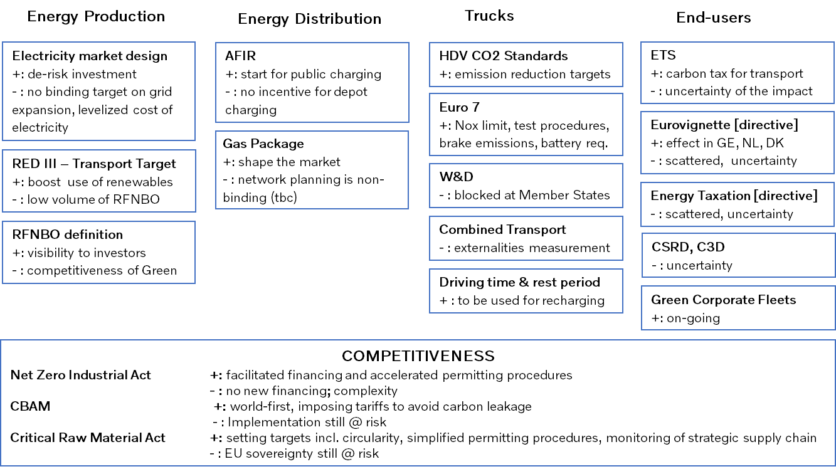
Figure 9: The European Legislative Frame towards 2030 (non-exhaustive view)
The transition can only be a success if we work all together as an ecosystem.
To succeed with the transition to sustainable transportation solutions, we need to reach a functioning end-to-end equation as a base. Products and service offerings are not all, we also need a total cost of ownership that is competitive and profitable, charging infrastructure in place, and fossil-free energy available. If any of these are lagging, we will not reach the goal and not succeed with the transition.
We see three crucial connected areas to be acted upon immediately:
1. Policy instruments need to be implemented at EU and member states at sufficient levels to bridge the cost gap during the transition phase from fossil-based transport solutions to sustainable transport solutions, and by that – create a strong growing demand. Today, there is scattered development and insufficient pace between EU member states to drive a fast and much needed adoption for ZEV solutions.
2. Additional clean energy production needs to come in place, already within the next 5 years, with an increasing need up to 2040. The additional power needs to be predictable enough for our customers to be able to continue with just-in-time deliveries and meet the expectations of the industry and logistic sector.
3. Infrastructure investments are critical to ensure that our customers can get access to sustainable power and can operate efficiently with the new vehicles and maintain world-class efficiency in logistics.

Research and Innovation priorities
The road freight transport industry is experiencing unprecedent times, focusing on transitioning the freight transport system to zero emission and automated solutions. Efforts should support this transition in real world with practical implementation and by addressing bottlenecks.
Successful transformation requires changes across the entire logistics system, including the business model, digitalization, vehicle technologies, infrastructure, and energy (and not only one of these single components).
The system cost associated with the whole transport system is critical, impacting market acceptance of zero-emission transport. This affects affordability, inclusivity, cost-competitiveness, economic sustainability, and overall resilience. As illustrated in the picture below, business models and innovative incentives systems – as well as infrastructure – must be especially addressed in the upcoming R&I program FP10.

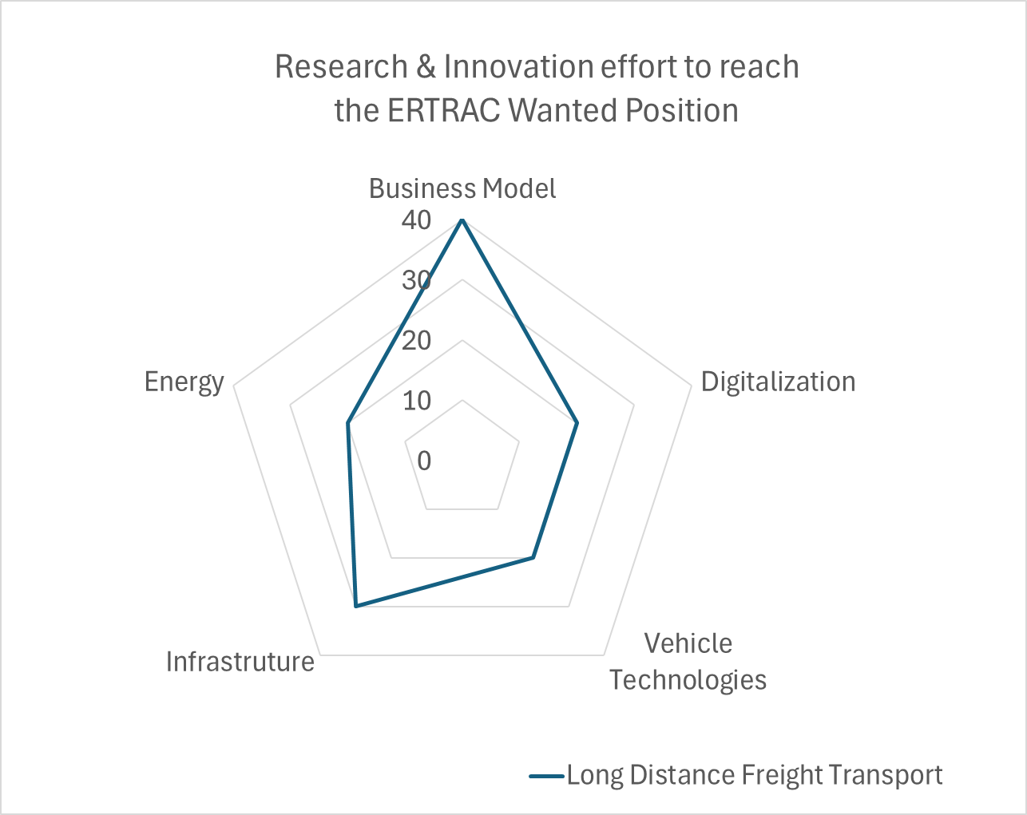
Figure 10: Gap Analysis

Outlined below are the Research and Innovation priorities to address the (above) identified gaps. More detailed information describing these Research and Innovation priorities is provided in the annex.

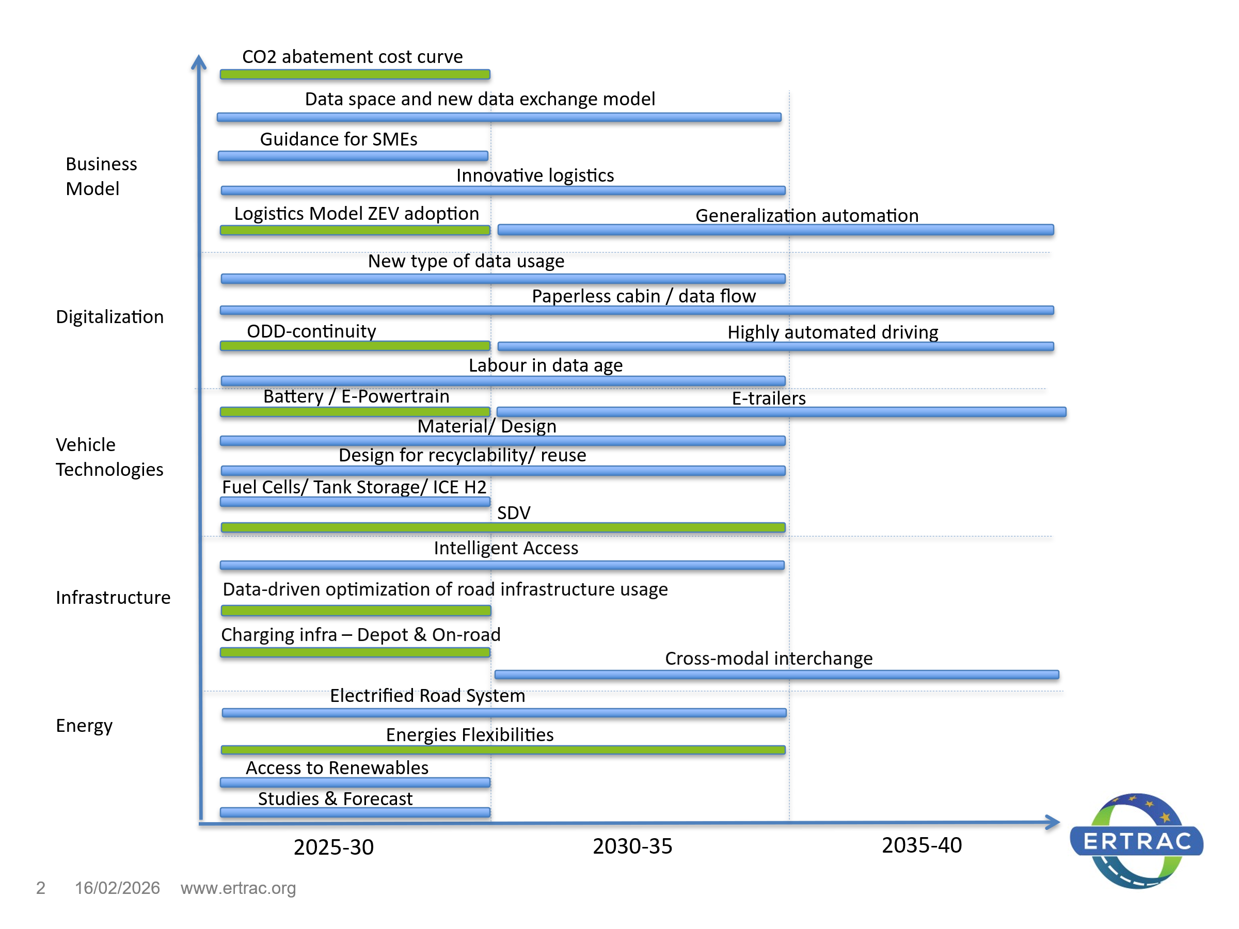
Figure 11: Research and Innovation priorities to be addressed in FP10 (Green: Prio 1; Blue: Prio 2)

Appendix – Detailed description of research and innovation priorities
Title | R&I Priorities | Solutions / End-users Benefits | Gaps / Challenges
Business Model
CO2 abatement cost curve | Understand the CO2 abatement cost curve (with a distinction of market segments) considering energy price and tax trajectories | This will show which technologies will be competitive once CO2 abatement cost is included | How to support the demand-side and the off-take of ZEV during the transition phasis?  Need for practical tools/software to model and make projections  Public policy should ensure that the transition to zero emission techs matches with business models.
Sustainable Logistics Model for ZEV adoption | Develop scalable logistics and business models for zero-emission vehicle adoption, focusing on long-haul operations | Develop guidance for optimal transition paths:  1. Mission-driven vehicles combination = build the vehicle combination strategy that complies with legislation and is the best transport solutions using the optimized technology mix  2. Truck/fuel (end-to-end) system TCO monitoring tool | Build the right ecosystems – integrating end users, vehicles, energy and (digital and physical) infrastructure (for energy and road), into specific networks and corridors – so that zero emissions freight transport becomes affordable, while supporting system stability
Guidance for SMEs | Guidance for SMEs | Low emission optimized technology mix.  Usage of digital platforms / marketplaces, usage of dynamic/adaptive planning systems, etc. | Decision-making help for what is the best techno/ mission profile for SMEs
Generalization of automation | Business models for generalization of automated freight transport and logistics, including economic benefits of lower levels of automation (<L4) for road safety improvements | Platooning and hub to hub transport (hub coordination)  Go from testing (pilots) to generalization of CAV (at least corridors) | Distinguishing key differences in requirements for trucks when compared to passenger cars à regulation adaptation to be studied  Monetization of idle vehicle periods (e.g., energy storage, grid services)
Innovative logistics | Innovative logistics decarbonization pathways | New logistics schemes, EMS2 trailers (/ driver) swapping  Investigate allowances for ZEV e.g. night/ week-end trucks bans, parking provisions, etc. | Barriers in integrating new technologies within traditional logistics models and adopt zero emission vehicle
Data space and new data exchange model | New types of data exchange (disruptive innovation)  AI leveraging data handling | Leveraging on “data spaces” e.g. for local Traffic Management, L4 driving, road maintenance (live map and road condition updates, etc.), exchange with the energy sector. | Increase accessibility of data
Digitalization
Paperless cabin / data flow | Digitalization of road transport operations | Today, most of road transport operations go via paper. | Adoption barriers, interoperability issues across platforms, calibration and accuracy concerns, cybersecurity
New types of data usage | New ways of using data | Machine readable legislation  Digital enforcement with -e.g. CO2 measures, weight in motion, etc.  Intelligent access policies  Understand/ cluster the data available | Find the methodology to extract useful and relevant data, AI
Autonomous Driving | Cooperation between infrastructure and vehicle for autonomous driving  <L4 and >L4 | Infrastructure support in difficult situations - mostly at customs/borders, in tunnels, toll gates, hubs | Harmonized rules for L4 automation functions and the approval process across Europe, human factors
ODD-continuity | ODD-continuity in tunnels, borders, toll stations by active infrastructure support | Provide access to existing infrastructure (tunnels, cities) based on safety and sustainable requirements  Vehicle coordination: To orchestrate the movement of the automated trucks in terms of coordination of truck behaviour (vehicles will need to be guided by a centralized entity) | Need for standardized communication protocols, infrastructure investment requirements, regulatory barriers, public acceptance issues, technological maturity; legal and ethical considerations.  Data sharing limitations: need for real-time infrastructure updates. Digital resilience
Labour in data age | Investigate what will be the consequences of automation on the labour environment | Partly automated: driver adaptation and acceptance  Fully automated: driver role will become more of an operator role (planning, supervising, quality control, etc.) | Disruptive view of labour environment. Driver’s role. Automation will create new jobs related to operations, flows, surveillance and logistics planning, for example
Vehicle Technologies
Battery | Battery lifetime and energy density increase (incl. high voltage concepts) | Performance under extreme conditions (required power, road profiles, weather…)  Battery management to improve lifetime  Optimized chemistry vs. resilient EU supply chain | Battery performance, durability and cost
 | Battery sizing, optimization, modularity and recyclability (incl. transport) | Understand the business case impact of 2nd or 3rd life of the battery operations versus new battery acquisition | Cost for changing the battery with regards to sustainability – including circularity aspects (EoL, battery passport)
E-Powertrain | E-Powertrain | Power electronics, electric motors, transmission | Improve efficiency, packaging, durability, maintainability and cost
Fuel Cells | Fuel cells H2 | Novel membrane solutions (life time, temperature, PFAS). Cost reduction. Precious Group Metals reduction elimination | Eliminate PFAS  Increase operational temperature and lifetime
Tank storage | H2 Tank storage | Use of renewable and circular material. Improved H2 density and reduced tank | Carbon Fiber is costly and LCA is not good
H2 ICE | H2 ICE to decarbonized long distance freight transport system | ICE platforms adaptation for H2 combustion, with lower upfront costs and leveraging on existing manufacturing infrastructure | Optimization
Material/ Design | New material and design, considering material sovereignty | Incorporation of advanced materials for improved vehicle performance and reduced energy consumption. Novel Design and production models, including for supporting intramodality | Cost vs performance.  Need for standardized testing and certification procedures for new materials, vehicle safety and durability
Design for recyclability/ for reuse | Modular design within OEMs | Gains through maintenance and repair processes involving interchangeable modules. | Cost vs reparability, recycling and end-of-life processing. Transport issue
SVD | Software Defined Vehicle | Joined development of standardized electronic hardware & software building blocks and interfaces | Increased competitiveness and sovereignty
Infrastructure
Charging infra – On-road | On-road charging scheduling & booking (incl. MCS) | Understand public charging opportunities, costs and framework conditions (aligned with driving and rest time rules)  Dynamic allocation of energy and potential re-routing for vehicle charging vs vehicle flow.  Smart and connected space management (e.g. public parking overnight) | How to optimize charging utilization (profitability) with charging point availability (charging congestion), reliability, as well as route optimization considering charging (book a time slot, book& pay), Ensuring interoperability among different charging networks and platforms  Identify additional charger spots needed  Improve total cost of ownership
Charging infra – Depot | Cooperation between the owners of the premises (warehouses), the owners of the vehicles (SLP, transport operators) with local energy supply | Depot charging with alternative business case for vehicle standing still: New business model | Location of power need compared to energy/grid vulnerability.  How the vehicle could be used during charging in depot, when loading, during driver’s rest, etc.
HRS | Hydrogen Refuelling Station | Upscaling HRS for HDV (size, cost, flow rate) | HRS features
Road infra | Cooperation between infrastructure and vehicles for intelligent access | Develop Intelligent Access and data exchanges for information of the health of the infrastructure | Initial investment to be decided upon, and shared. Transparency of budget flows (to be earmarked to infra)
 |  | Optimize the usage of (road) infrastructure  Optimization of road maintenance | Pavement surface assessment and optimal planning of maintenance/repair actions  Structural health of pavements foundations and bridges (esp. linked to higher allowed weight for ZEVs)
 | Cross-modal interchange infrastructures for clean and automated logistics | SSTPAs with charging and automated features  Smart grid and fast charging infrastructure  Smart and automated connected space management (e.g. parking lots, terminal and storage areas)  Intelligent good handling: automated load handling self- and /or remote manoeuvring, smart loading units (in order for rail/ maritime/ roads to come together)  Interfaces towards the incoming and outgoing modes (including interfaces to traffic management and information systems) | Redesign the concept of parking areas, including overnight, loading areas with charging and automated features, etc.  Intermodal transports efficiency.  To support Multimodal integration with zero emission vehicles: rail-road, rail-inland waterways.
Energy
Access to Renewables | Access to renewable energy structure and new business models securing affordability | Renewable energy, sector coupling to use/create synergies between transport and energy sector
Studies & Forecast | Studies on available energy supply and transport | Projections on most likely future alternative energy carriers (availability, quality and price)  Scenarios for energy infrastructure investments | Reduce existing uncertainties  To support regulation, investment decisions and the market readiness of the transport sector. Balancing short-term costs with long-term benefits
Energy Flexibilities | Energy Flexibilities, grid capacity map, Flexible services agreements, …  Potential opportunities with V2X | LDFT as part of the energy system with incoming and outcoming flows. Management of energy flows. Benefits of Mix of charging solutions | Measure technical and business impact (different from cars)
ERS | New pathways for ERS scaling | Investigate new business model pathways for ERS scaling in Europe to become viable. E.g. Financed private entity approaches with several road owners, a toll road operator initiative, etc. | Evaluate business and energy benefits. Define most fruitful use cases, build scenarios for willingness to invest
Battery Swapping | Battery Swapping | Fast and safe automated swapping mechanisms, robust thermal and electrical interfaces  Enhance system reliability, real-time diagnostics, and integration with energy management systems for efficient grid interaction | Standardized, interoperable systems and scalable infrastructure to support wide adoption
E-trailers | E-trailers / B-trailers | Developing advanced energy management systems that optimize power sharing  Lightweight design, modular battery integration, and communication protocols to ensure seamless operation across various vehicle platforms and logistics scenarios | Lack of clear regulatory frameworks and technical standards, limited large-scale pilot projects and infrastructure for testing

ACEA Position Paper 2016, https://www.acea.auto/files/ACEA_Position_Paper_Reducing_CO2_Emissions_from_Heavy-Duty_Vehicles.pdf
Eurostat 2022, https://ec.europa.eu/eurostat/statistics-explained/index.php?title=Freight_transport_statistics_-_modal_split
https://ec.europa.eu/eurostat/web/products-eurostat-news/w/ddn-20240925-2
ACEA The Automobile Industry Pocket Guide 2024-2025, https://www.acea.auto/files/ACEA-Pocket-Guide-2024-2025-1.pdf
European Commission: Directorate-General for Mobility and Transport, EU transport in figures – Statistical pocketbook 2023, Publications Office of the European Union, 2023, https://data.europa.eu/doi/10.2832/319371
Regulation (EU) 2024/1610, http://data.europa.eu/eli/reg/2024/1610/oj
EU: Reducing CO2 emissions from heavy-duty vehicles, 2024, https://climate.ec.europa.eu/eu-action/transport/road-transport-reducing-co2-emissions-vehicles/reducing-co2-emissions-heavy-duty-vehicles_en
ERTRAC, Safe Road Transport Research Roadmap, https://www.ertrac.org/wp-content/uploads/2022/07/ERTRAC-Safety-Roadmap-2021.pdf
EU, Road freight fatalities, 2022, https://road-safety.transport.ec.europa.eu/sites/default/files/2024-03/collision_matrix_2024_update.png
Definition of “users” - https://www.ertrac.org/wp-content/uploads/2024/03/ERTRAC-Decarbonizing-Freight-Transport-Paper-2024.pdf
Industry Experts, Researchers Put Charging Systems for Electric Trucks to the Test | NREL
Definition of ‘zero pollution’ according to EU Action Plan “Towards a zero pollution for Air, Water and Soil”, https://eur-lex.europa.eu/legal-content/EN/TXT/?uri=CELEX%3A52021DC0400&qid=1623311742827
https://www.acea.auto/zero-emission-tracker/
Drivers for and barriers to electric freight vehicle adoption in Stockholm - ScienceDirect
Potential Impact of Gartner's Tech Trends on Manufacturing
Beyond Moonshots: AI Agents Will Come To Earth In 2025
Artificial Intelligence and Cybersecurity: Balancing Risks and Rewards, World Economic Forum, White paper, January 2025. WEF_Artificial_Intelligence_and_Cybersecurity_Balancing_Risks_and_Rewards_2025.pdf
Circularity and Competitiveness - ERTRAC
https://www.cisco.com/c/m/en_us/solutions/industrial-networking-report.html
https://www.iru.org/news-resources/newsroom/global-truck-driver-shortage-double-2028-says-new-iru-report
https://www.ertrac.org/wp-content/uploads/2024/06/ERTRAC-Vision-2050-adopted-ERTRAC-Plenary-24-06-2024.pdf
https://zefes.eu/
https://h2accelerate.eu/
https://electreon.com/projects/france
Wandel, S., Sternberg, H., & Hill, G. (2014). Regulatory telematics for heavy vehicles-Policy and innovation implications from the intelligent access program (IAP). In HVTT13. International Forum for Road Transport Technology.
ITF (2018), “Polices to Extend the Life of Road Assets”, ITF Research Reports, OECD Publishing, Paris.
https://modiproject.eu/
2035 Joint Impact Assessment of Greenhouse Gas Reducing Pathways for EU Road Transport Jakob Rogstadius, Mats Alaküla, Patrick Plötz, Francisco J. Márquez-Fernández, Lina Nordin, March 2024, https://ri.diva-portal.org/smash/get/diva2:1846969/FULLTEXT03.pdf
e49b6a7a-8f8a-4901-b8ba-b9f88aed8683_en
https://www.acea.auto/files/ACEA_Eurelecric_recommendations_Decarbonising_heavy-duty_road_transport_The_role_of_grids.pdf
https://eepublicdownloads.blob.core.windows.net/public-cdn-container/clean-documents/Publications/Position%20papers%20and%20reports/2023/231006_ENTSO-E_Position%20Paper_Deployment%20of%20Heavy-Duty%20EVs%20and%20Impact%20on%20the%20Power%20System.pdf
https://insieme.energy/
https://www.piarc.org/en/order-library/39717-en-Electric%20Road%20Systems%20-%20Collection%20of%20Case%20Studies
https://transport.ec.europa.eu/document/download/89b3143e-09b6-4ae6-a826-932b90ed0816_en?filename=Communication%20-%20Action%20Plan.pdf
https://www.connectedautomateddriving.eu/about/fame/
https://www.connectedautomateddriving.eu/about/fame/
UNECE paves the way for automated driving by updating UN international convention | UNECE
Background document. Input for the global multistakeholder high level conference on governance for web 4.0 and virtual worlds, 31 March – 1 April 2025, https://ec.europa.eu/newsroom/dae/redirection/document/113701
https://federate-sdv.eu/
https://mobility-dataspace.eu/
https://gaia-x.eu/
https://modiproject.eu/
The European road freight rate development benchmark, Q4 2024, IRU.
Albin Engholm, Ida Kristoffersson, Anna Pernestal, Impacts of large-scale driverless truck adoption on the freight transport system, Transportation Research Part A: Policy and Practice, Volume 154, 2021, Pages 227-254, https://doi.org/10.1016/j.tra.2021.10.014.
https://www.europarl.europa.eu/legislative-train/theme-a-european-green-deal/file-revision-of-the-weights-and-dimensions-directive?sid=8001
Report on the implementation of the amendments to Directive 96/53/EC introduced by Directive (EU) 719/2015, 24.3.2023, https://transport.ec.europa.eu/document/download/45e1073e-373a-4156-966b-0523915dec9f_en?filename=SWD_2023_70_implementation_report_amendments_dir_96_53.pdf
https://zefes.eu/
Intelligent Access (IA): current NRA practices, CEDR Working Group Road Freight Transport, CEDR Technical Report 2022-01, June 2022.
Wandel, S., Sternberg, H., & Hill, G. (2014). Regulatory telematics for heavy vehicles-Policy and innovation implications from the intelligent access program (IAP). In HVTT13. International Forum for Road Transport Technology.
CEDR project ISAC, Intelligent Surface Access Community, https://www.cedr.eu/docs/view/665deb5d14e90-en
CEDR Road Freight Corridor Management https://www.cedr.eu/wg-road-freight-transport
https://setoproject.eu/
https://www.ertrac.org/news/new-road-transport-vision-2050-adopted-by-ertrac/
https://commission.europa.eu/topics/strengthening-european-competitiveness/eu-competitiveness-looking-ahead_en
https://single-market-economy.ec.europa.eu/news/enrico-lettas-report-future-single-market-2024-04-10_en
Roadmap to the Physical internet, Alice, 2020. https://www.etp-logistics.eu/wp-content/uploads/2022/11/Roadmap-to-Physical-Intenet-Executive-Version_Final-web.pdf
WG CAD Roadmap 2023
https://www.iru.org/what-we-do/being-trusted-voice-mobility-and-logistics/environment/iru-green-compact
https://www.etp-logistics.eu/wp-content/uploads/2019/12/Alice-Zero-Emissions-Logistics-2050-Roadmap-WEB.pdf
Questions and Answers: CountEmissionsEU. https://ec.europa.eu/commission/presscorner/detail/en/qanda_23_3774
https://transport.ec.europa.eu/transport-modes/road/weights-and-dimensions_en

